PHOTO RELEASE Contact
John Xuereb
610-520-6140 X202
jxuereb@alvare.com

Intellectual Father of UT Southwestern Medical School
Honored in Bronze
Statue of Dr. Donald Seldin created by world-renowned sculptor Zenos Frudakis

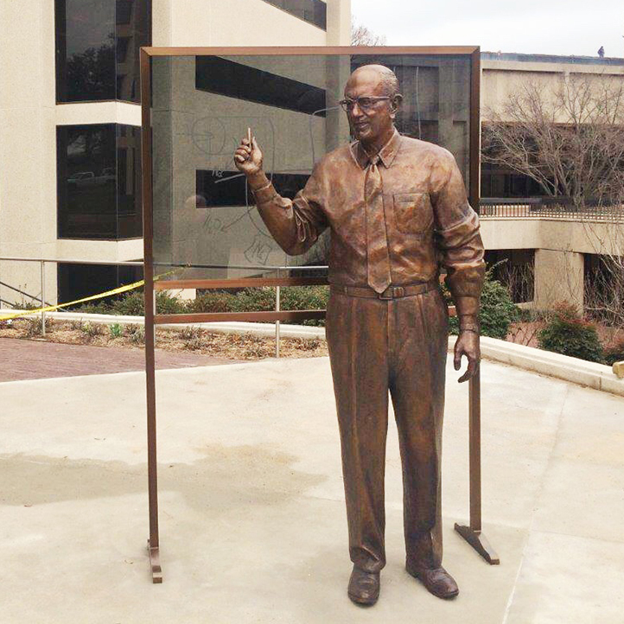
Seven foot-tall bronze figure of Donald Wayne Seldin, M.D., created by sculptor Zenos Frudakis and unveiled in a ceremony on the campus of UT Southwestern Medical Center on March 16, 2015.

DALLAS -- March 16, 2015 -- In a ceremony on the campus of the University of Texas Southwestern Medical Center, a statue was unveiled of Donald Wayne Seldin, M.D., UT Southwestern Professor and Chairman Emeritus of Internal Medicine, UT System Professor of Internal Medicine, and the William Buchanan Chair in Internal Medicine. Dr. Seldin is widely revered as one of the greatest chairs of Internal Medicine in American medical history, and considered the intellectual father of UT Southwestern Medical School.

The seven-foot sculpture of Dr. Seldin, commissioned by UT Southwestern Medical Center, was created in clay by Philadelphia-based sculptor Zenos Frudakis and cast in bronze at the Laran Bronze Foundry in Chester, Pa. The sculpture depicts UT Southwestern’s esteemed professor at the blackboard. The dedication plaque reads: “As Chairman of Internal Medicine for 35 years (1952-1988), he inspired generations of physician-scientists, creating the intellectual foundation on which UT Southwestern was built.”

Attendees of the unveiling ceremony on March 16, included Dr. Donald Seldin and Dr. Ellen Taylor-Seldin; Daniel Podolsky, M.D., president of UT Southwestern Medical Center; UT Southwestern Medical Center Nobel laureates Dr. Joseph Goldstein and Dr. Michael Brown; and sculptor Zenos Frudakis.

About Dr. Donald Seldin
Dr. Seldin was born in New York City. He received his BA degree from New York University and his MD from Yale University School of Medicine. His residency in Internal Medicine was at New Haven Hospital. He was appointed to the faculty at Yale from 1944 to 1951 when he was recruited to UT Southwestern Medical School. He was appointed Chairman of Internal Medicine from 1952 to 1988, at which time he became Chairman Emeritus. He has trained literally thousands of medical students and residents, and many of his students occupy high academic positions. He continues to be active in teaching and writing. http://profiles.utsouthwestern.edu/profile/16511/donald-seldin.html -

About Zenos Frudakis
Philadelphia-based sculptor Zenos Frudakis has been a professional working sculptor for nearly four decades. In that time he has created more 100 monumental works in public and private collections throughout the US and abroad. By scholarship he earned a Bachelor of Fine Arts degree from the Pennsylvania Academy of Fine Arts and a Master in Fine Art from the University of Pennsylvania. Zenos' emphasis has been the figure and the portrait, as demonstrated in his many monumental figure/portrait works, individual portrait busts and bas-reliefs. He excels at expressing the character and vitality of his subjects while capturing an accurate likeness. Zenos portfolio includes figure sculpture, animals, bas-reliefs, portraits -- both busts and paintings -of living and historical individuals, and poetic/philosophical sculpture with a post-modern sensibility.. www.zenosfrudakis.com
# # #

